### SQL commands and examples

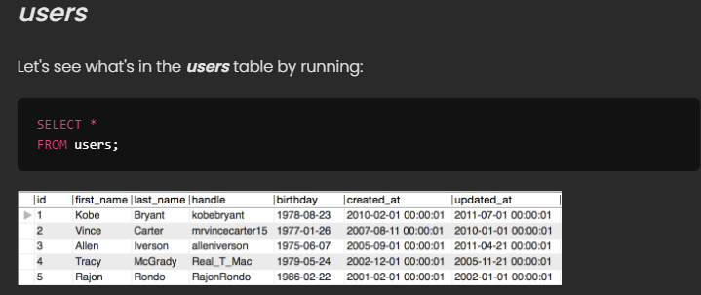

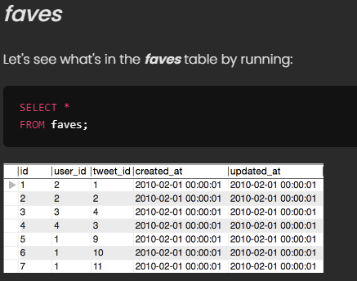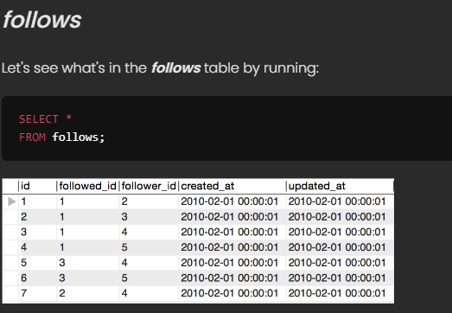

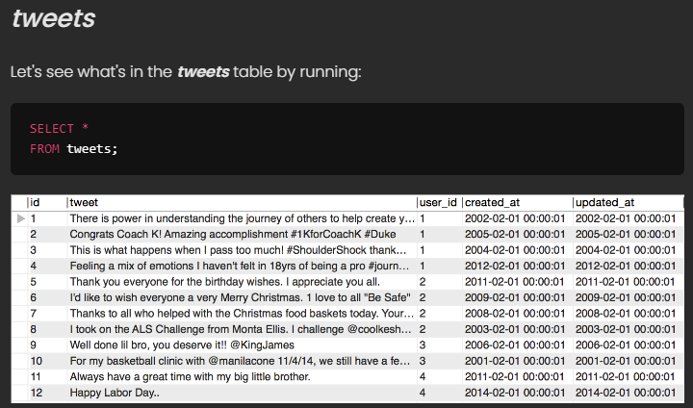

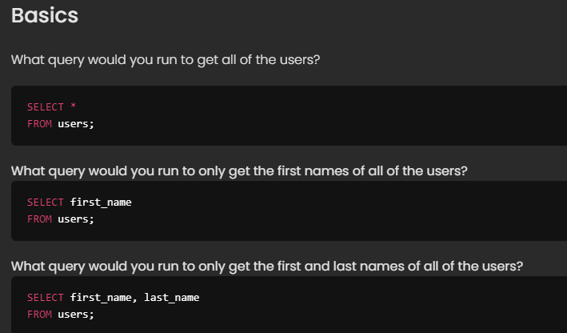

­­

­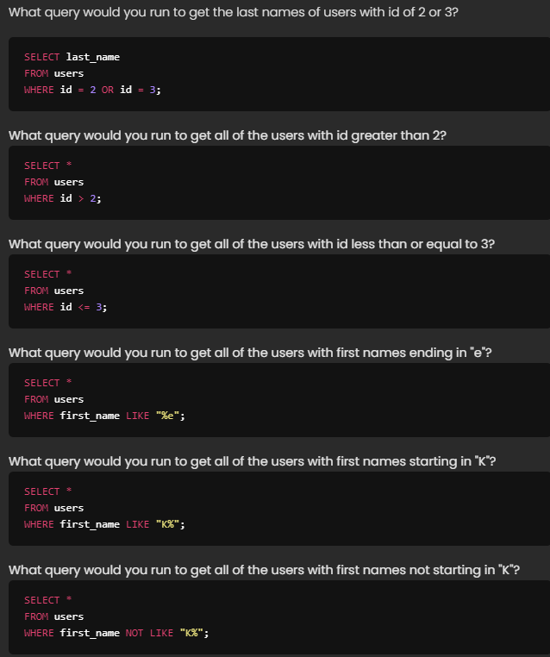

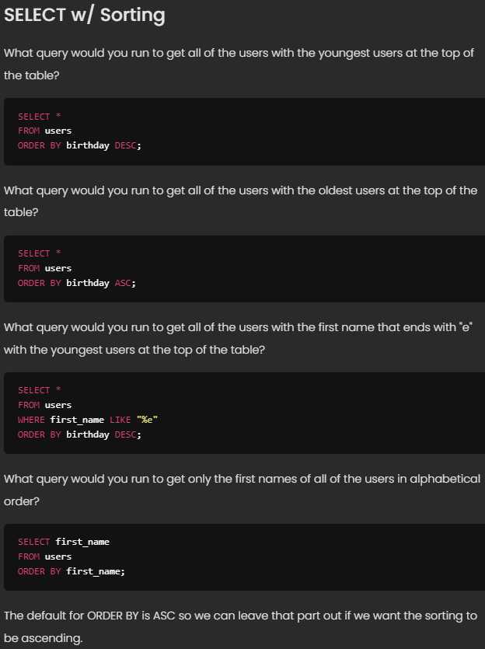

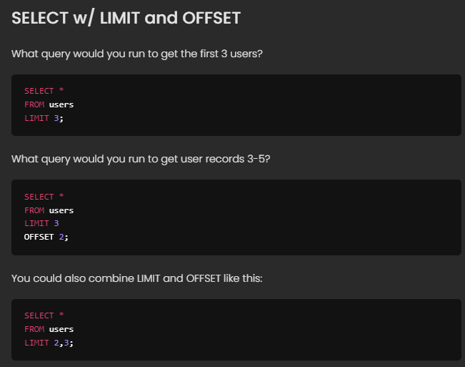

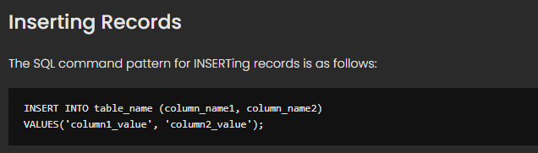

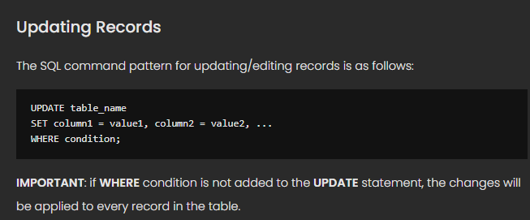

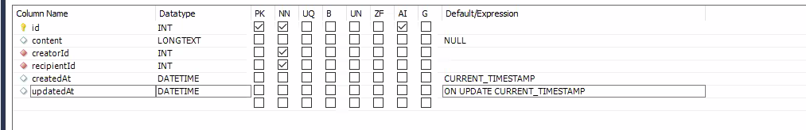

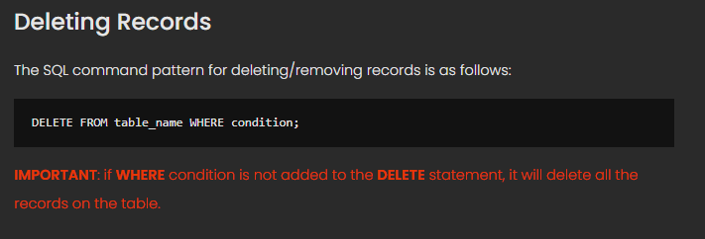

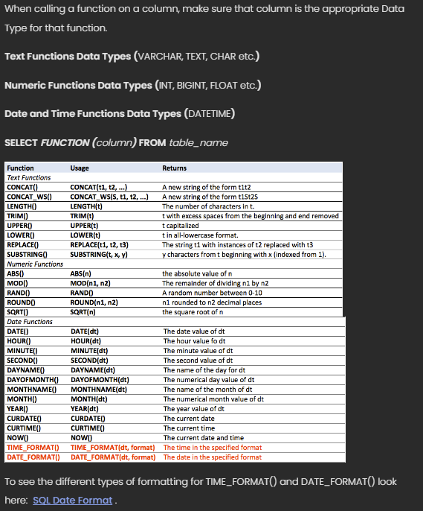

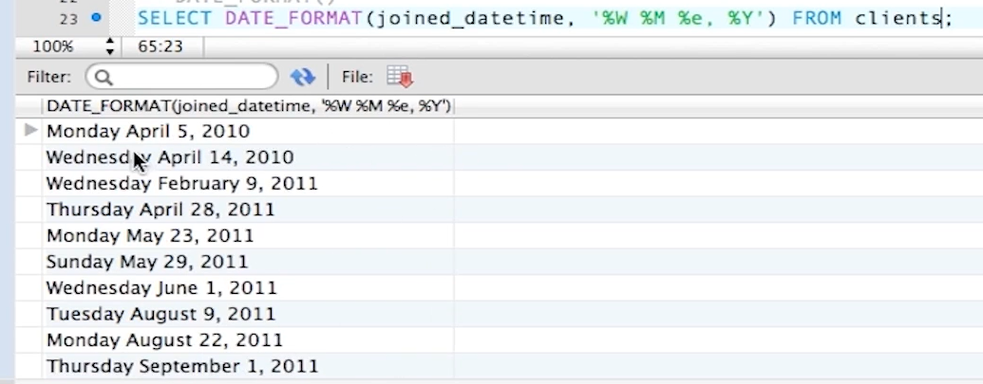

**Python**[**strftime**](https://docs.python.org/3/library/datetime.html#strftime-and-strptime-format-codes)**cheatsheet  
🐍🐍🐍**

| **Code** | **Example** | **Description** |
| --- | --- | --- |
| %a | Sun | Weekday as locale’s abbreviated name. |
| %A | Sunday | Weekday as locale’s full name. |
| %w | 0 | Weekday as a decimal number, where 0 is Sunday and 6 is Saturday. |
| %d | 08 | Day of the month as a zero-padded decimal number. |
| %-d | 8 | Day of the month as a decimal number. (Platform specific) |
| %b | Sep | Month as locale’s abbreviated name. |
| %B | September | Month as locale’s full name. |
| %m | 09 | Month as a zero-padded decimal number. |
| %-m | 9 | Month as a decimal number. (Platform specific) |
| %y | 13 | Year without century as a zero-padded decimal number. |
| %Y | 2013 | Year with century as a decimal number. |
| %H | 07 | Hour (24-hour clock) as a zero-padded decimal number. |
| %-H | 7 | Hour (24-hour clock) as a decimal number. (Platform specific) |
| %I | 07 | Hour (12-hour clock) as a zero-padded decimal number. |
| %-I | 7 | Hour (12-hour clock) as a decimal number. (Platform specific) |
| %p | AM | Locale’s equivalent of either AM or PM. |
| %M | 06 | Minute as a zero-padded decimal number. |
| %-M | 6 | Minute as a decimal number. (Platform specific) |
| %S | 05 | Second as a zero-padded decimal number. |
| %-S | 5 | Second as a decimal number. (Platform specific) |
| %f | 000000 | Microsecond as a decimal number, zero-padded on the left. |
| %z | +0000 | UTC offset in the form ±HHMM[SS[.ffffff]] (empty string if the object is naive). |
| %Z | UTC | Time zone name (empty string if the object is naive). |
| %j | 251 | Day of the year as a zero-padded decimal number. |
| %-j | 251 | Day of the year as a decimal number. (Platform specific) |
| %U | 36 | Week number of the year (Sunday as the first day of the week) as a zero padded decimal number. All days in a new year preceding the first Sunday are considered to be in week 0. |
| %W | 35 | Week number of the year (Monday as the first day of the week) as a decimal number. All days in a new year preceding the first Monday are considered to be in week 0. |
| %c | Sun Sep 8 07:06:05 2013 | Locale’s appropriate date and time representation. |
| %x | 09/08/13 | Locale’s appropriate date representation. |
| %X | 07:06:05 | Locale’s appropriate time representation. |
| %% | % | A literal '%' character. |

**Platform-specific directives**

The full set of format codes supported varies across platforms, because Python calls the platform C library's strftime() function, and platform variations are common. To see the full set of format codes supported on your platform, consult the [strftime(3) documentation](http://man7.org/linux/man-pages/man3/strftime.3.html).

The Python docs contain all the format codes that the C standard (1989 version) requires, and these work on all platforms with a standard C implementation. Note that the 1999 version of the C standard added additional format codes. These include codes for non-zero-padded numbers, that can be obtained by appending a dash (-) (UNIX) or hash (#) (Windows) after the percent (%) sign.

**Source**

This cheatsheet was built from the [Python standard library strftime documentation](https://docs.python.org/3/library/datetime.html#strftime-and-strptime-format-codes). See [github.com/mccutchen/strftime.org](https://github.com/mccutchen/strftime.org/) for the build source code.

**See also**

You might also like [PyFormat.info](https://pyformat.info/) or the interactive [strfti.me](https://www.strfti.me/).

Last updated Thu Jul 15 16:02:31 2021.

Fixing the format “NONE” issue

jinja2.exceptions.UndefinedError: 'None' has no attribute 'strftime'

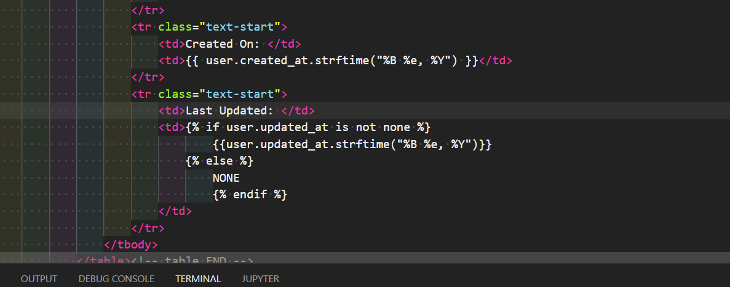

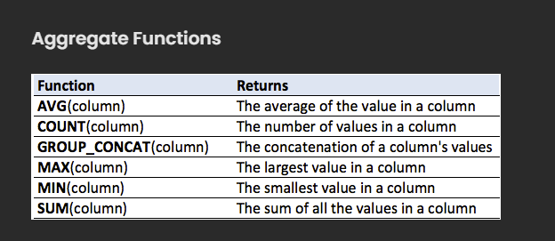

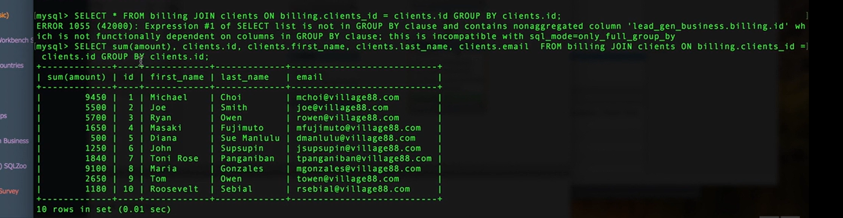

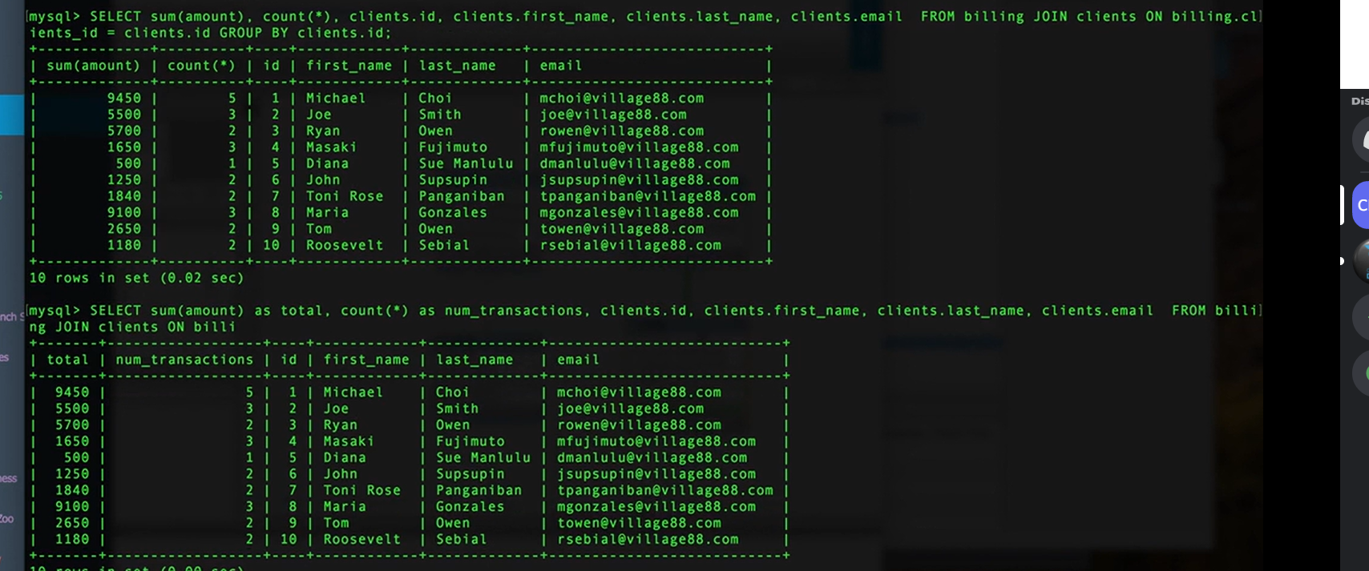

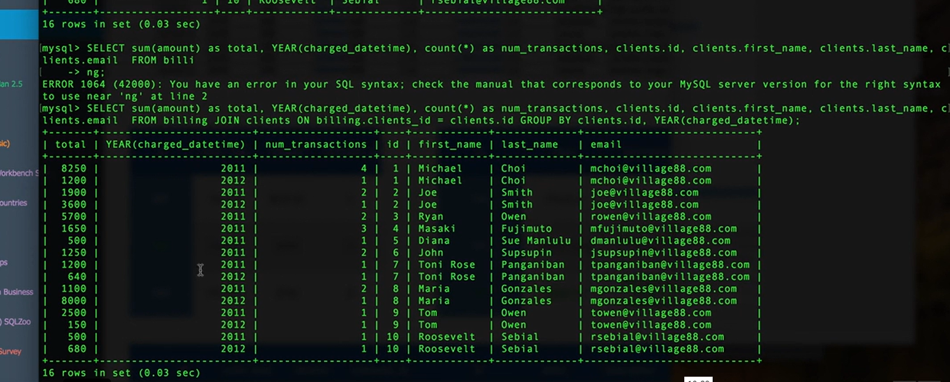

FK info and delete / cascading info

https://www.techonthenet.com/sql_server/foreign_keys/foreign_delete.php